Minutes - November 15, 2021 Meeting Agenda SNSA BOD

6:00 - Call to order

In attendance: Andy Anderson, Ben Mandel, Colin Quinn-Hurst, Dave Yadon, Liz Addis, Susan Engel, Excused: Jason Halloran, Matt Halloran

Guests: Dan Rey-Bear, Dee Finchamp – Karma Consulting, Diana Dupuis - Washington State Parks, Lara Gricar – Washington State Parks, Trevor Finchamp – Karma Consulting

Action Items:
- Nordic kids coordinator to with State Parks, Diana and Lara, on details of process for program coordinator to access cabinet/lodge.
- Track on spreadsheet comparing current Race Team participants versus those who have turned in forms and paid
- Provide a front end google form on the program web pages for expressing interest in Race Team/T-Team
- Work out out a way for one-off Adult Lesson participants to be able to pay online
- Recruit volunteers for Winterfest weekend
- Colin to ask Mike Burns for formal introduction or email introduction with previous contacts
- During fundraising, inform potential sponsors that title sponsorships of Race Team and WinterFest are taken.
- If anyone has fundraising contacts, please send them to Trevor
- Looking for a prize to give away through the Refer-a-Friend raffle at the end of the month
- For Masters Program, Colin to work with Trevor and Matt Halloran to add inquiry form and training calendar to program web page and set up online system for $150 registration
- Adaptive Program via Robin Redmond is recruiting people to be blind skier guides.
- Add Dan Rey-Bear to list of Board of Directors in organizational paperwork and on website, following unanimous approval of adding Dan as a board member.
- May move December BOD meeting up one week to Monday, December 13.

Minutes:

- Approve Minutes from Oct 19, 2021
- Motion by Andy Anderson, seconded by Dave Yadon, approved
- Lara Gricar/Diana Dupuis - Updates from WA State Parks
- Hired a groomer with lot of experience plowing narrow winding roads, great equipment operator, great attitude. Familiar with working odd hours and overnight, very familiar working with snow. Joe Nelson will help him.
- Equipment is currently in good shape
- With switch of graveyard plow operators to other roles, need to hire two new plow operators
- Selkirk Lodge will stay closed for the season due to mask mandate in enclosed public spaces, do not want to ask staff or volunteers to police masks
- Will be easy to open the Selkirk Lodge when the time comes.
- Downhill area doing 7 days a week through March this year, helping spread people out
- Finished nordic area map for winter distribution
- Will be doing grooming report again
- First Day Ski – two people already volunteered to help already, Sam and Jane Joseph. Don’t necessarily need more people at this point to volunteer.
    - 0930 start
    - MSSP Staff to assist
    - Work with Trevor to advertise this event
    - Rex’s volunteer report

- Other topics: Nordic Kid coordinator could use some space in the lodge for storing equipment, for access to cabinet with program supplies, and to be available at a single location to assist participants.
  - Action item: Work with State Parks on details of process for program coordinator to access cabinet/lodge.
  - Matt Halloran currently in process of hiring coordinator

- Dan Rey-Bear introduction - potential BOD, Attorney by Profession
  - Skis with family
  - From Albuquerque, in Spokane 8 years, skis in town and at Mt. Spokane
  - Interested originally in Selkirk Lodge renovation options
  - Happy to help with legal skills
  - Enthusiasm to help with moving project forward for Selkirk Lodge

- Treasurer's report – Liz
  - Total assets are growing
  - Last year had received $2k for JNQ fundraising at this time
  - Last year had done outreach for trail maintenance fundraising
  - Have been receiving donations from organizations, such as United Way
  - Race team registrations and income are down compared to last year, concern related to head coach budget compared to anticipated income:
    - Action Item: Track on spreadsheet comparing current Race Team participants versus those who have turned in forms and paid
    - Action Item: Provide a front end google form on the program web pages for expressing interest in Race Team/T-Team
  - Nordic Kids: Income up compared to last year, program structure adjusted compared to last year. Allows for more registrations. Opened registrations and advertising earlier than last year.
  - Reimbursing trail costs: will see if any reimbursement requests come in for saws or other equipment. Electric hedge trimmers have apparently been working well and State Parks is considering purchase of more trimmers.
- Grooming and Trails, Adult lessons - Dave
  - GAC meeting update – had last GAC meeting after last board meeting in October pleased to have Jason Halloran and Jason Jablonski on the committee.
    - Reviewed founding documents specifying roles of the committee.
    - Trail work conditions were not ideal over the summer due to fire concerns as well as due to logging activities by Inland Paper. Reduced cutting of alder on Inland Paper property, due to concerns with hunting season.
    - Still working out what people can do with private equipment.
    - Work in progress between George and Sam and Trevor to keep website updated so people can go out on their own. Website has been updated with new information since last month.
    - Quartz Mountain: With increased popularity of Quartz Mountain lookout, Joe Nelson with Washington State Parks is looking at options for creating a loop to Quartz Mountain lookout, connecting to Abner’s.
  - Adult lessons
    - Lisa has put together the instructors and process to get people signed up for WinterFest.
    - People are participating in Methow PSIA December training
    - One of the Methow instructors is on the national team for PSIA, aiming to bring her here later this winter for local instruction
    - Winterfest planning
      - Action item: Working out a way for one-off Adult Lesson participants to be able to pay online
        - Will take burden off instructors for collecting checks, simplifying process for instructors and participants
      - Winterfest Title Sponsor :Ramble Raven
      - Skijor clinic - likely not on snow
      - Action Item: Recruit volunteers for Winterfest weekend
- Race Team/Transition Team - Ben
  - Assistant coach update – Erin Jacobsen, moved to Spokane from Wyoming, has coaching experience with High School team. Interested in potentially being Assistant Coach and wanting to learn more about Spokane Nordic in general.
    - Ben spoke with her and connected her with Jason Jablonski for race team, Ted Haskell for T-Team, and Matt Halloran for Nordic Kids
    - May help fill shortage of female coaches in PNSA
  - Fall training update
    - There’s now a schedule, Tuesday/Thursday, sporadic in terms of who shows up
    - Issues in terms of other competing sports
  - JNQ fundraising
    - Mike Burns is stepping away from fundraising
    - Look at support that had come in at this time last year, $2k by now
    - Action item: Colin to ask Mike for formal introduction or email introduction with previous contacts
- Nordic Kids - Matt
  - Coordinator job in the works, hiring in process
  - Background checks
    - Use Washington State Patrol online form, $11 per report
- Karma Update - Trevor and Dee
  - Membership Drive Update
    - Making progress, looking for single large prize for raffle
  - Sponsors
    - Fitness Fanatics title sponsor of Race Team
    - Fitness Fanatics also sponsored maps
      - Fitness Fanatics has come through in a huge way in sponsorships
    - Action item: During fundraising, inform potential sponsors that title sponsorships of Race Team and WinterFest are taken.
    - If anyone has contacts, please send to Trevor
    - Action Item: Still looking for a prize to give away through the Refer-a-Friend raffle at the end of the month
      - REI may be a potential sponsor
      - Any ideas through Spokane Nordic would be welcome
      - Any gift you can give multiple of would be ideal
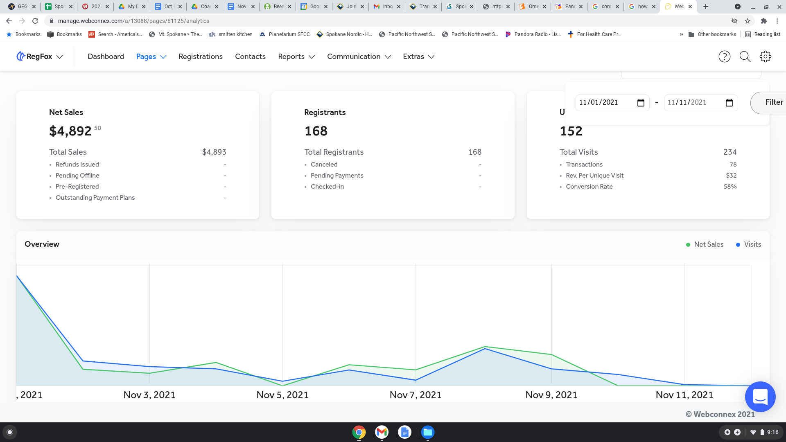
  - Sponsorship Plan
- Asset management
  - Van - winter storage – squared-away
- Master Ski Program – Andy
  - Been kicking that off, 12 people at first meeting
  - Looking at charging $150 for that program
  - First practice only three people there
  - Fluid program for this first year
  - Action Item: Colin to work with Trevor and Matt Halloran to add inquiry form and training calendar to program web page and set up online registration system for program
- Mountain Host - Andy
  - With this program, fall under some of the rules of the State Parks as it will be on the mountain, so it will fall under Volunteer Vaccination requirement https://drive.google.com/file/d/1lsdVkLDw5JWDsvQhE2vo69tzt4saFPFS/view?usp=sharing
  - Joel will be doing recruiting and getting people signed up
  - First Day ski volunteers will also be under these requirements
- Skijor - Susan
  - Barkerbeiner - Feb 27
    - If Lodge opens, that would be the date for hosting the Barkebeiner. Organizer Kate Burns will not host if lodge is closed.
    - In the past, Spokane Nordic would buy an insurance rider to host skijoring clinics, and would have done fundraising to pay for that
    - Won’t fundraise and buy an insurance rider if the event won’t happen. No point in buying insurance rider if Selkirk Lodge is unavailable to use.
  - Two educational clinics
    - If lodge is closed, anticipate doing educational clinics via zoom.
- Adaptive
  - If any questions are received by the Board, Robin Redmond would like to ensure that they are directed to her as usual.
  - Action Item: Adaptive Program via Robin Redmond is recruiting people to be blind skier guides.
  - Etiquette information will be distributed.
- Motion: Approve Dan Rey-Bear as Spokane Nordic board member, seconded
  - Unanimous approval
  - Action Item: Add Dan Rey-Bear to list of Board of Directors in organizational paperwork and on website.
- Action item: Schedule December meeting. May move December BOD meeting up one week to Monday, December 13

Meeting Adjourned 7:30 PM

